##dictionary

dict1={'name':'zara','age':7,'class':'first','name':'trang'}

print(type(dict1))

print(dict1)

print("keys",dict1.keys())

print("values",dict1.values())

print("items",dict1.items())

print("dict['name']:",dict1['name'])

print("dict['age']:",dict1['age'])

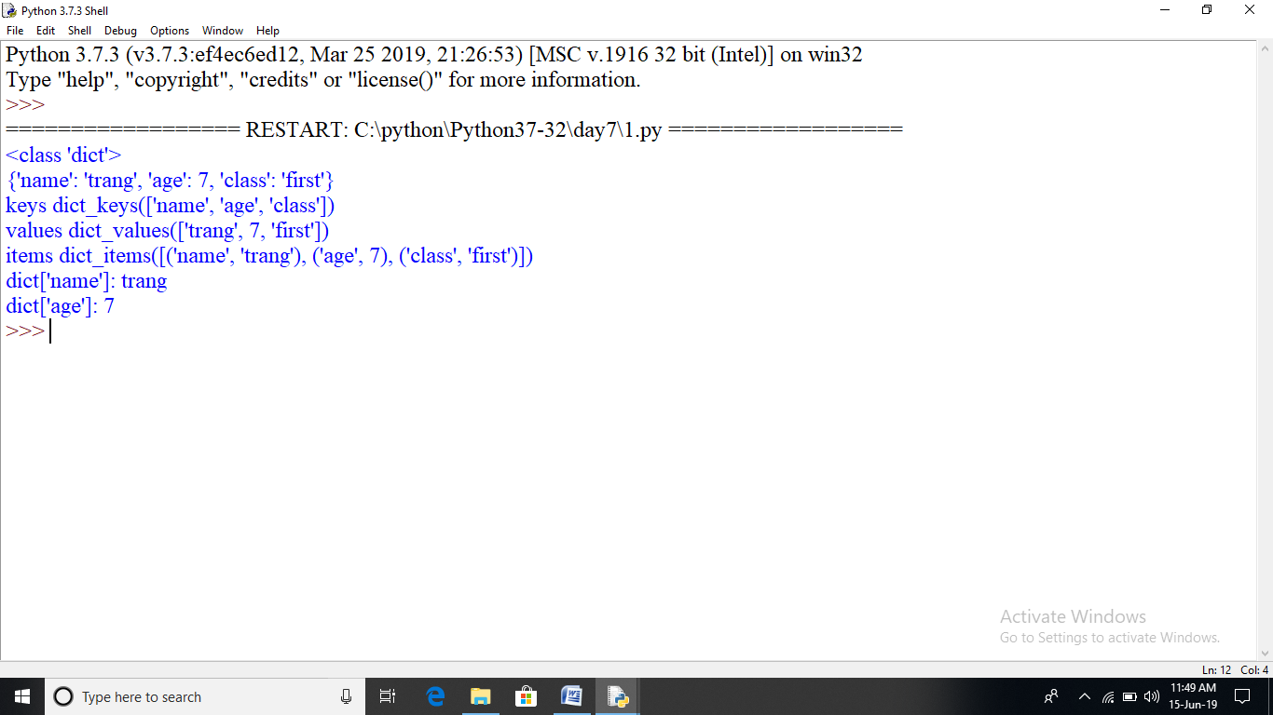

## COLOR SELECTION

def printblue():

print("you chose blue!\n")

return

def printred():

print("you chose red!\n")

return

def printorange():

print("you chose orange!\n")

return

def printyellow():

print("you chose yellow!\n")

return

def choice():

print("0:blue")

print("1:red")

print("2:orange")

print("3:yellow")

print("4:quit")

return

colorselect={0:printblue,1:printred,2:printorange,3:printyellow}

selection=0

while True:

if selection==4:break

choice()

selection=int(input("select a color option"))

if(selection>=0)and(selection<4):

colorselect[selection]()

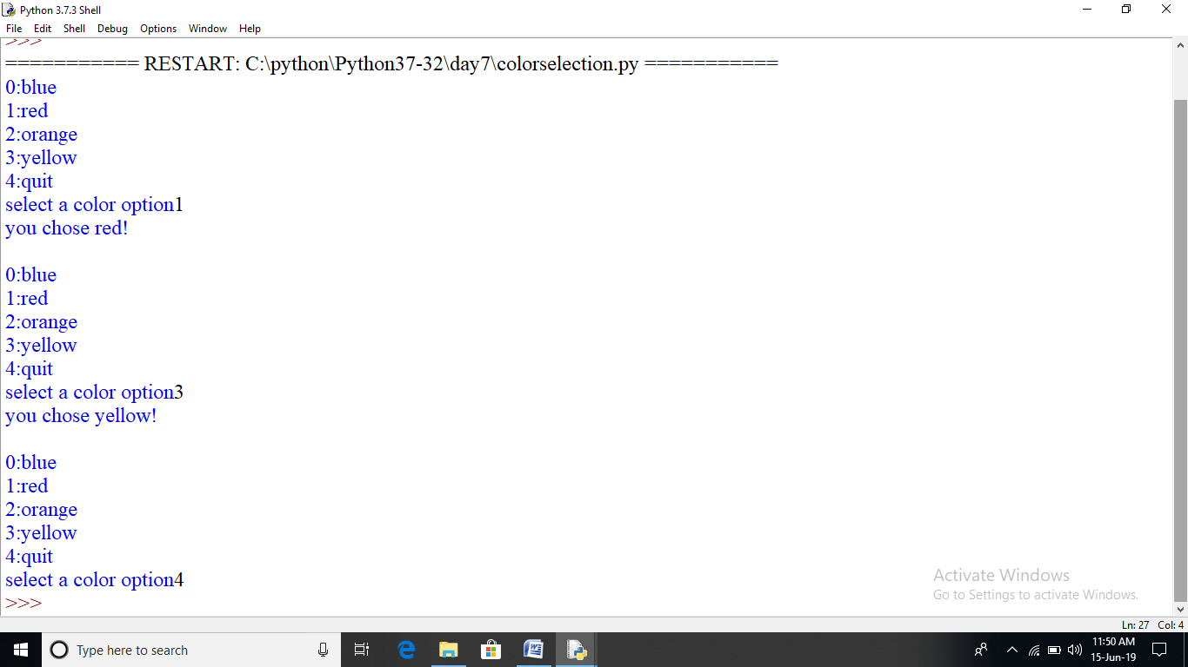

##DIVISION BY ZERO ERROR USING ASSERT

def div(a,b):

assert(b!=0),"division by zero is not defined"

return a/b

try:

print(div(20,3))

print(div(100,20))

print(div(55,0))

except AssertionError as ob:

print(ob)

print("thank you")

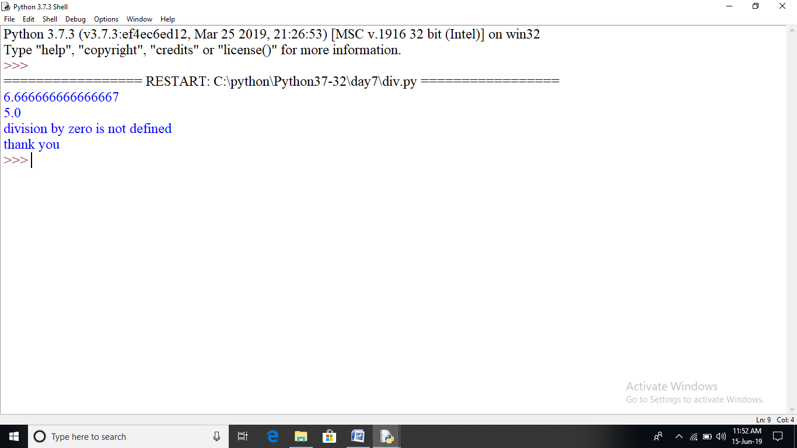

##temperature using ASSERTION

def kelvintofahrenheit(temperature):

assert(temperature>=0),"colder than absoulte zero"

res=((temperature-273)*1.8)+32

return res

try:

print(kelvintofahrenheit(273))

print(kelvintofahrenheit(505.78))

print(kelvintofahrenheit(-5))

except AssertionError as ob:

print(ob)

print("thank you")

